View-

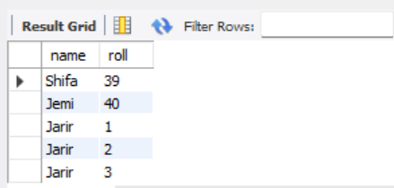

create view stu_info as select name,roll from STUDENT_DATA;

select * from stu_info;

trigger-

student data

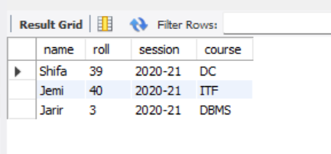

Table3-

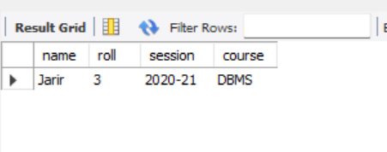

create trigger table5 after insert on STUDENT_DATA for each row insert into table3 values(new.name,new.roll,new.session,new.course);

INSERT INTO STUDENT_DATA(name,roll,session,course) VALUES('Jarir',03,'2020-21','DBMS');

select * From STUDENT_DATA;

select * from table3;

***View-***

***Main table: student_data***

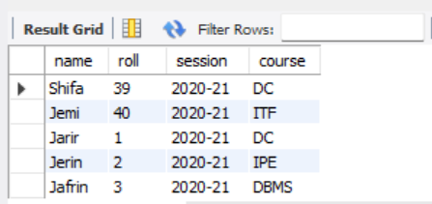

***View table:stu_info***

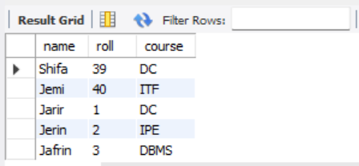

create view stu_info as select name,roll,course from STUDENT_DATA;

select * from stu_info;

***View table:stu_info2***

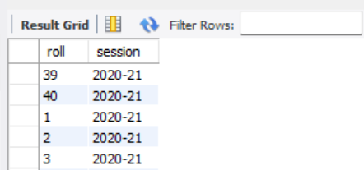

create view stu_info2 as select roll,session from STUDENT_DATA;

select * from stu_info2;

***view table join operation:***

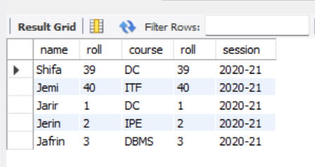

select stu_info.name,stu_info.roll,stu_info.course,stu_info2.roll,stu_info2.session from stu_info join stu_info2 on stu_info.roll=stu_info2.roll;

***view table update operation:***

***Before:***



***update:***

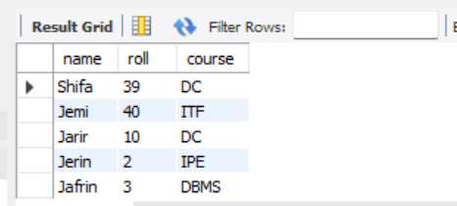UPDATE stu_info SET roll= 10 WHERE roll=01;

***view table delete operation:***

***Before:***



***Delete:***

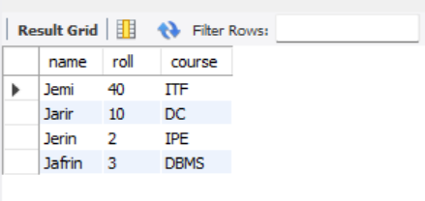

***Trigger: before diye***

***Main table: student_data***



***After triggering insert operation main table: student_data***

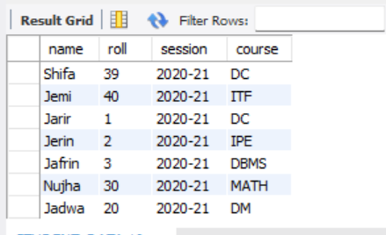

***After triggering insert operation trigger table:table3***

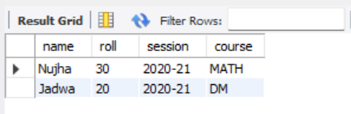

create trigger table5 before insert on STUDENT_DATA for each row insert into table3 values(new.name,new.roll,new.session,new.course);

-- insert

INSERT INTO STUDENT_DATA(name,roll,session,course) VALUES('Nujha',30,'2020-21','MATH');

INSERT INTO STUDENT_DATA(name,roll,session,course) VALUES('Jadwa',20,'2020-21','DM');

select * From STUDENT_DATA;

select * from table3;

***After triggering update operation main table: student_data***

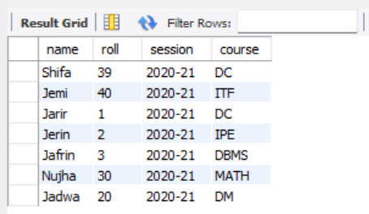

***After triggering update operation trigger table:table3***

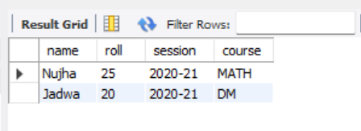

-- update

UPDATE table3 SET roll= 25 WHERE roll=30;

select * From STUDENT_DATA;

select * from table3;

***After triggering delete operation main table: student_data***

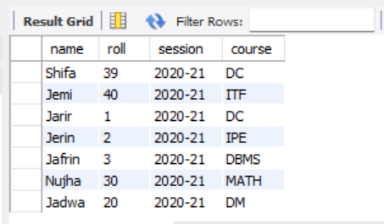

***After triggering delete operation trigger table:table3***

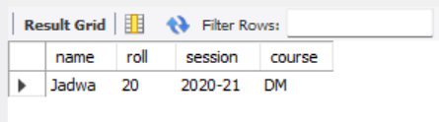

-- delete

delete from table3 where name='Nujha';

select * From STUDENT_DATA;

select * from table3;

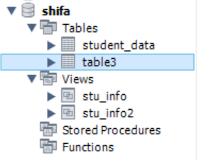

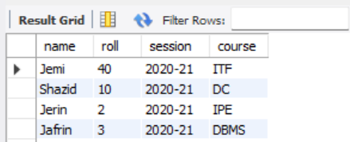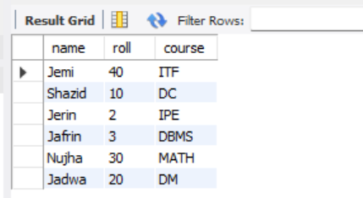

***Trigger: after diye***

***Main table: student_data***

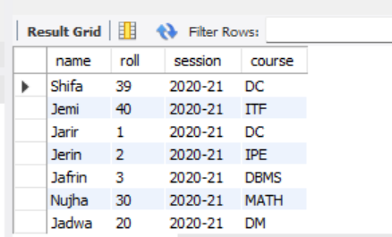

***After triggering insert operation trigger table:table3***

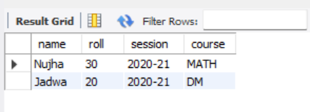

create trigger table5 after insert on STUDENT_DATA for each row insert into table3 values(new.name,new.roll,new.session,new.course);

-- insert

INSERT INTO STUDENT_DATA(name,roll,session,course) VALUES('Nujha',30,'2020-21','MATH');

INSERT INTO STUDENT_DATA(name,roll,session,course) VALUES('Jadwa',20,'2020-21','DM');

select * From STUDENT_DATA;

select * from table3;

***After triggering update operation main table: student_data***

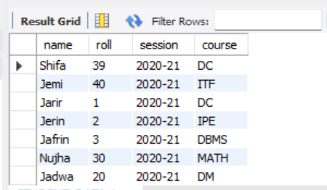

***After triggering update operation trigger table:table3***

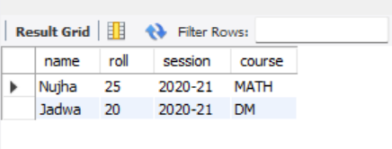

***After triggering delete operation main table: student_data***

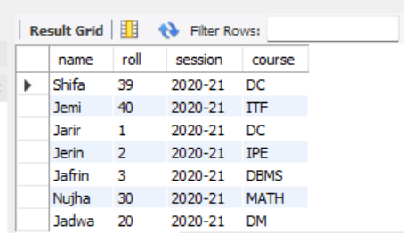

***After triggering delete operation trigger table:table3***

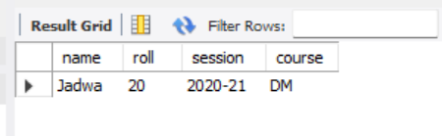

Triggering korar por trigger table a update,delete operation ager gulu/uporer gulu

Triggering korar por main table a update,delete operation

Triggering update:

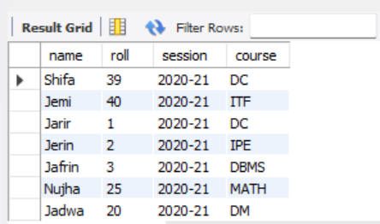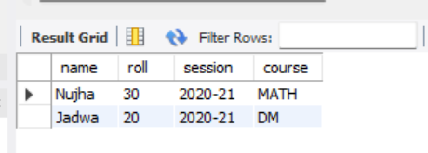

Triggering delete:

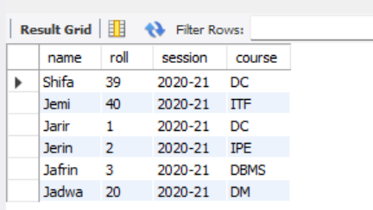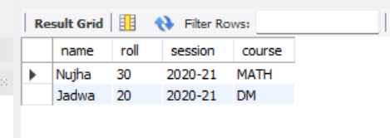

-- main table

-- update

UPDATE STUDENT_DATA SET roll= 25 WHERE roll=30;

select * From STUDENT_DATA;

select * from table3;

-- delete

delete from STUDENT_DATA where name='Nujha';

select * From STUDENT_DATA;

select * from table3;

Trigger insert

Main table

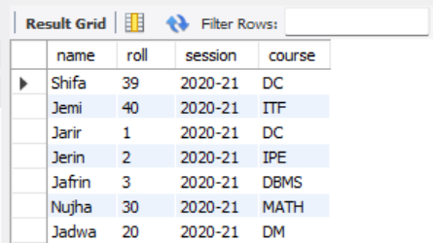

Trigger table

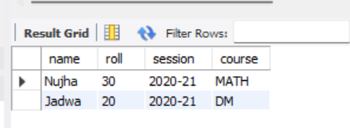

Trigger update

Main table

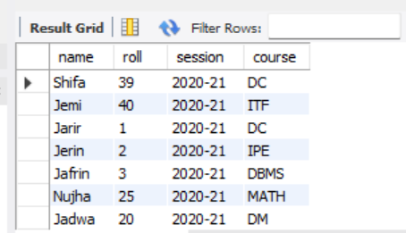

Trigger table

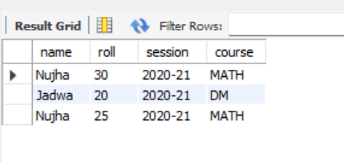

Trigger delete

Main table

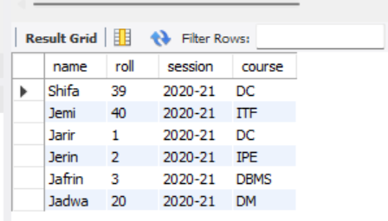

Trigger table

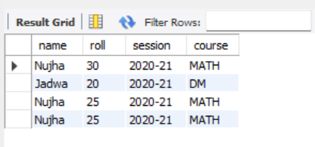

Trigger insert create

Main Trigger table

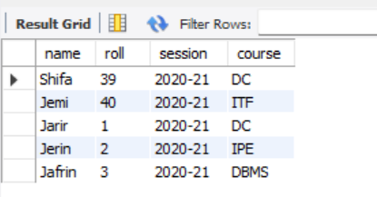 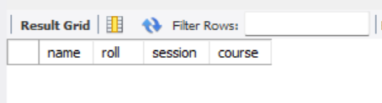

Trigger update create

Main Trigger table

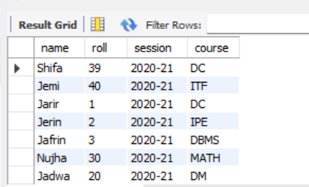 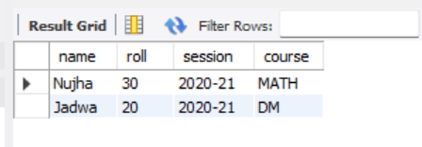

Trigger delete create

Main Trigger table

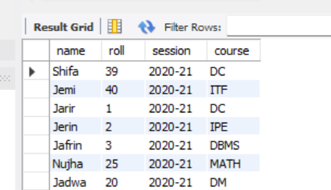

-- trigger

-- Create Table

create table table3(

name varchar(50),

roll int(30),

session varchar(30),

course varchar(30)

);

-- insert

create trigger table5_insert after insert on STUDENT_DATA for each row insert into table3 values(new.name,new.roll,new.session,new.course);

select * From STUDENT_DATA;

select * from table3;

INSERT INTO STUDENT_DATA(name,roll,session,course) VALUES('Nujha',30,'2020-21','MATH');

INSERT INTO STUDENT_DATA(name,roll,session,course) VALUES('Jadwa',20,'2020-21','DM');

select * From STUDENT_DATA;

select * from table3;

-- update

create trigger table5_update after update on STUDENT_DATA for each row insert into table3 values(new.name,new.roll,new.session,new.course);

select * From STUDENT_DATA;

select * from table3;

UPDATE STUDENT_DATA SET roll= 25 WHERE roll=30;

select * From STUDENT_DATA;

select * from table3;

-- delete

create trigger table5_delete after delete on STUDENT_DATA for each row insert into table3 values(old.name,old.roll,old.session,old.course);

select * From STUDENT_DATA;

select * from table3;

delete from STUDENT_DATA where name='Shifa';

select * From STUDENT_DATA;

select * from table3;